# CS 255 System Design Document Template

## UML Diagrams

### UML Use Case Diagram

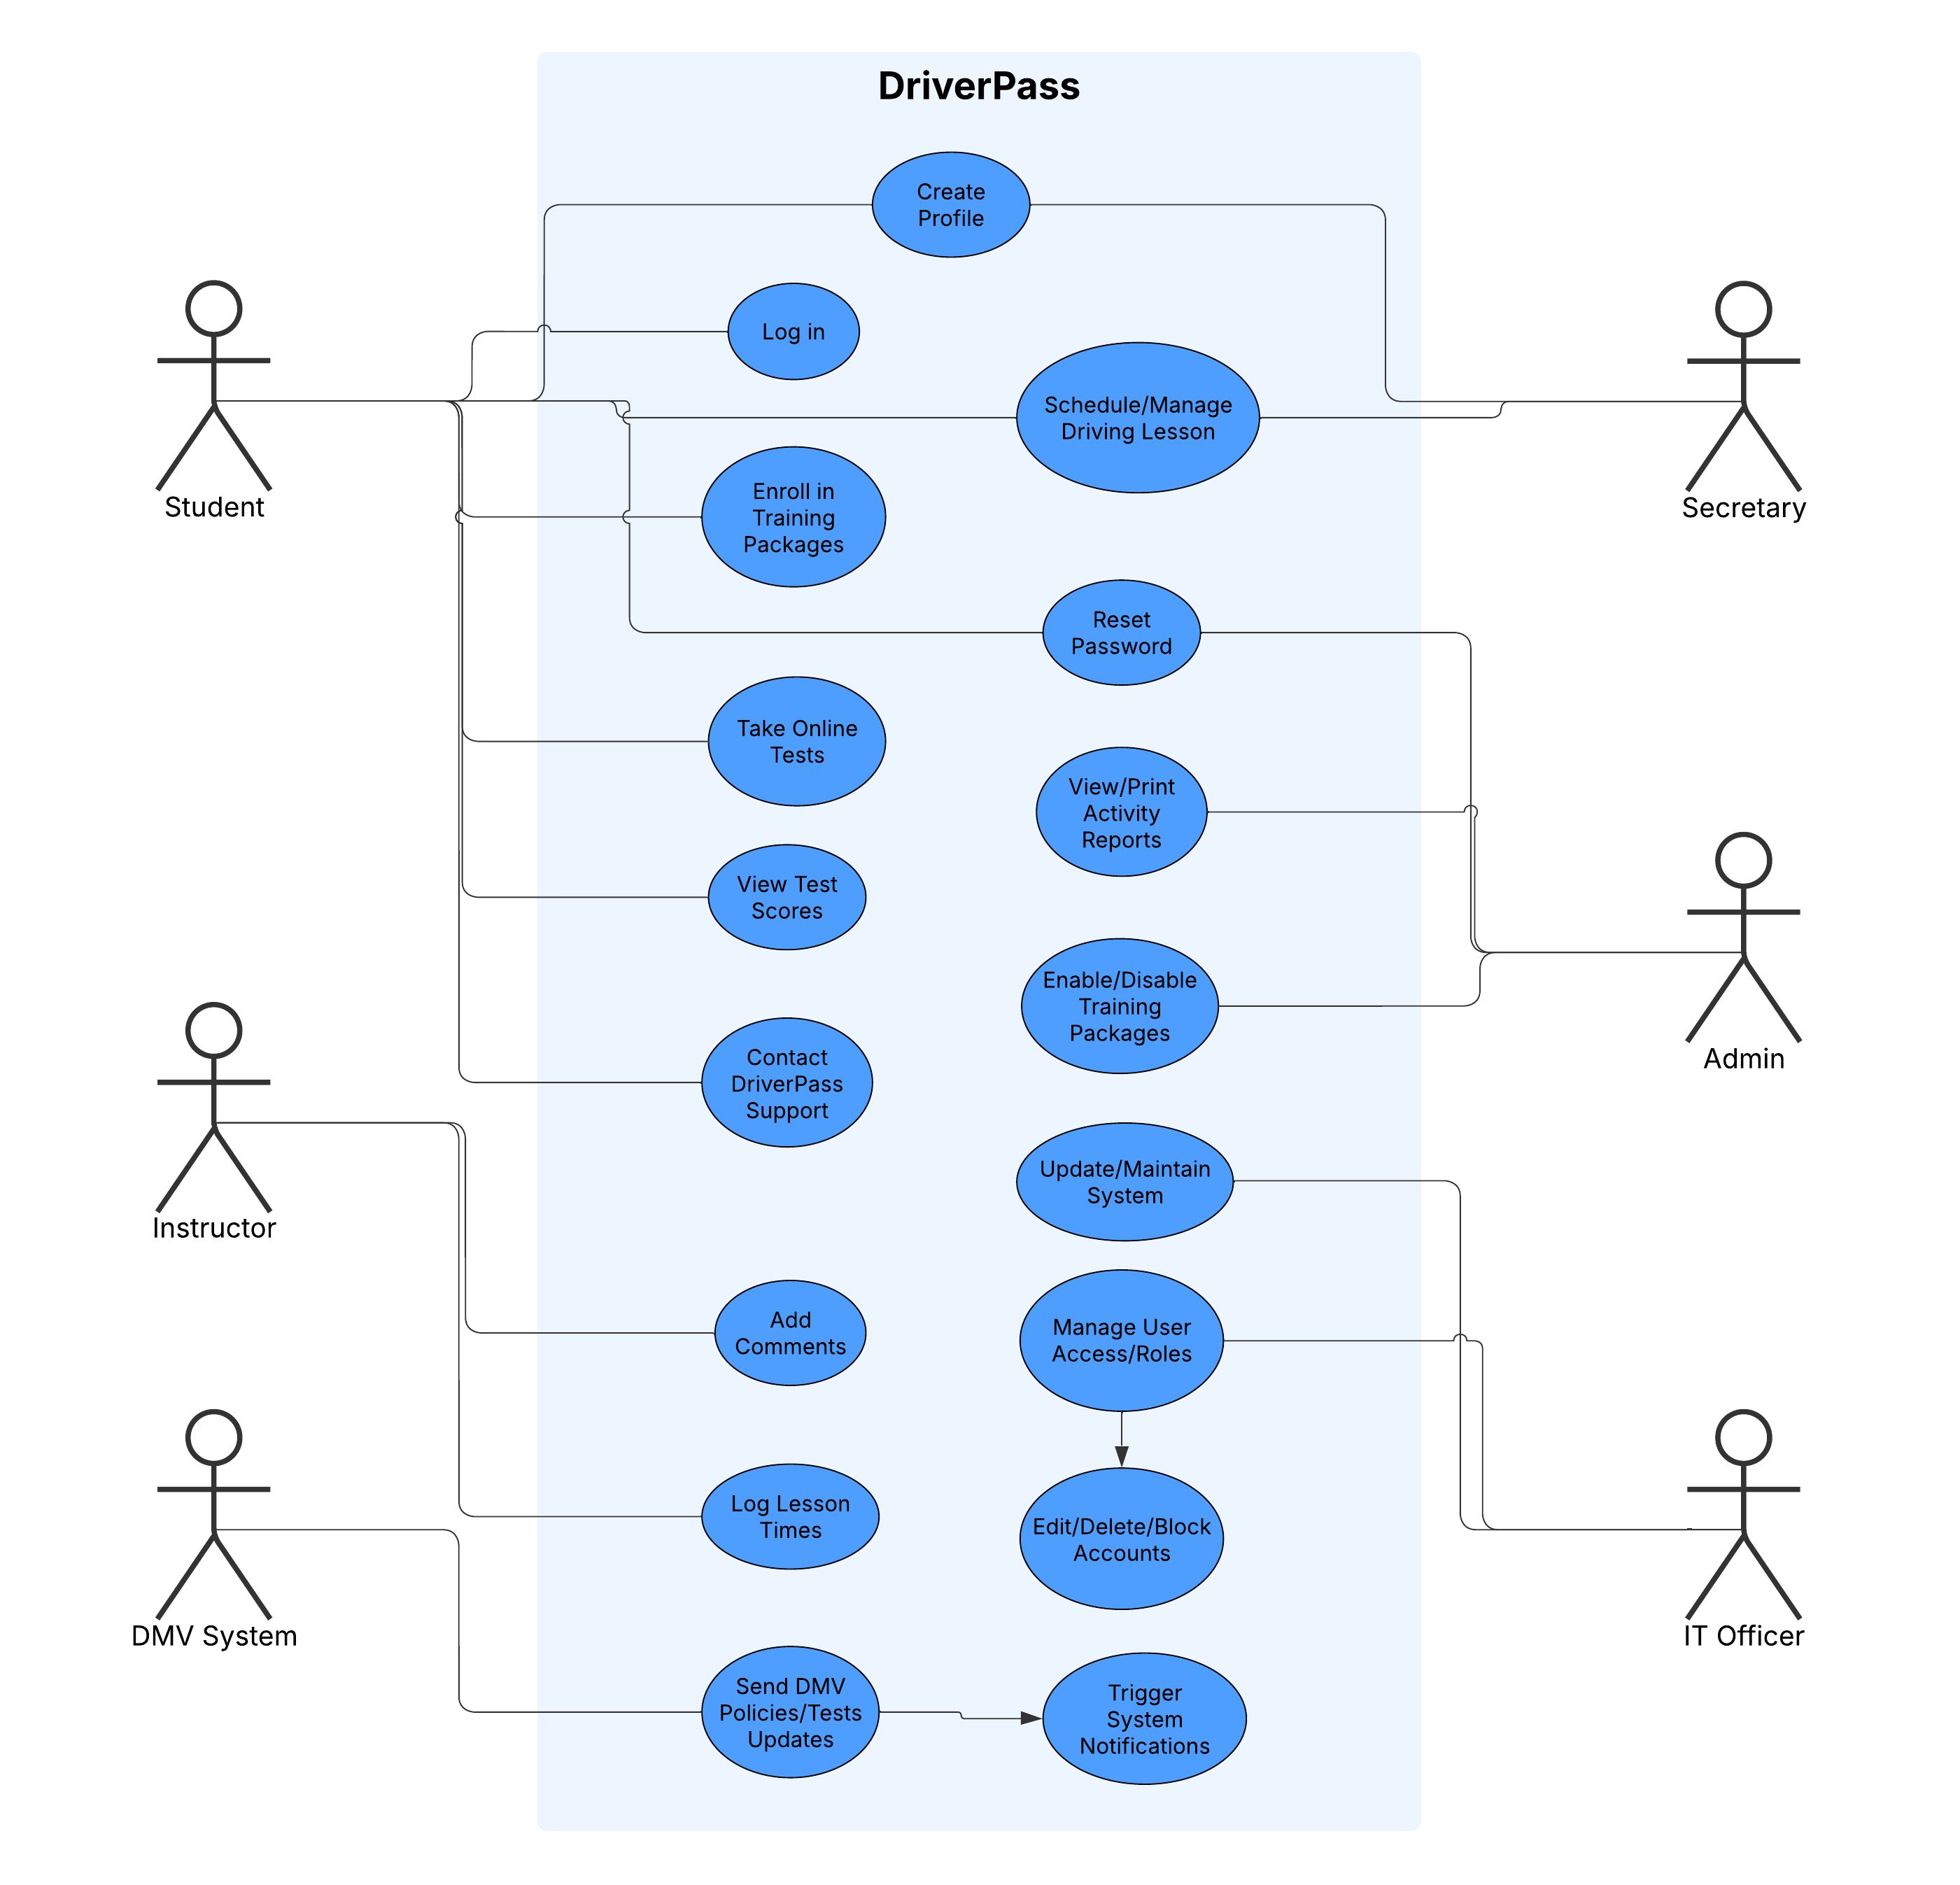

### UML Activity Diagrams

### UML Sequence Diagram

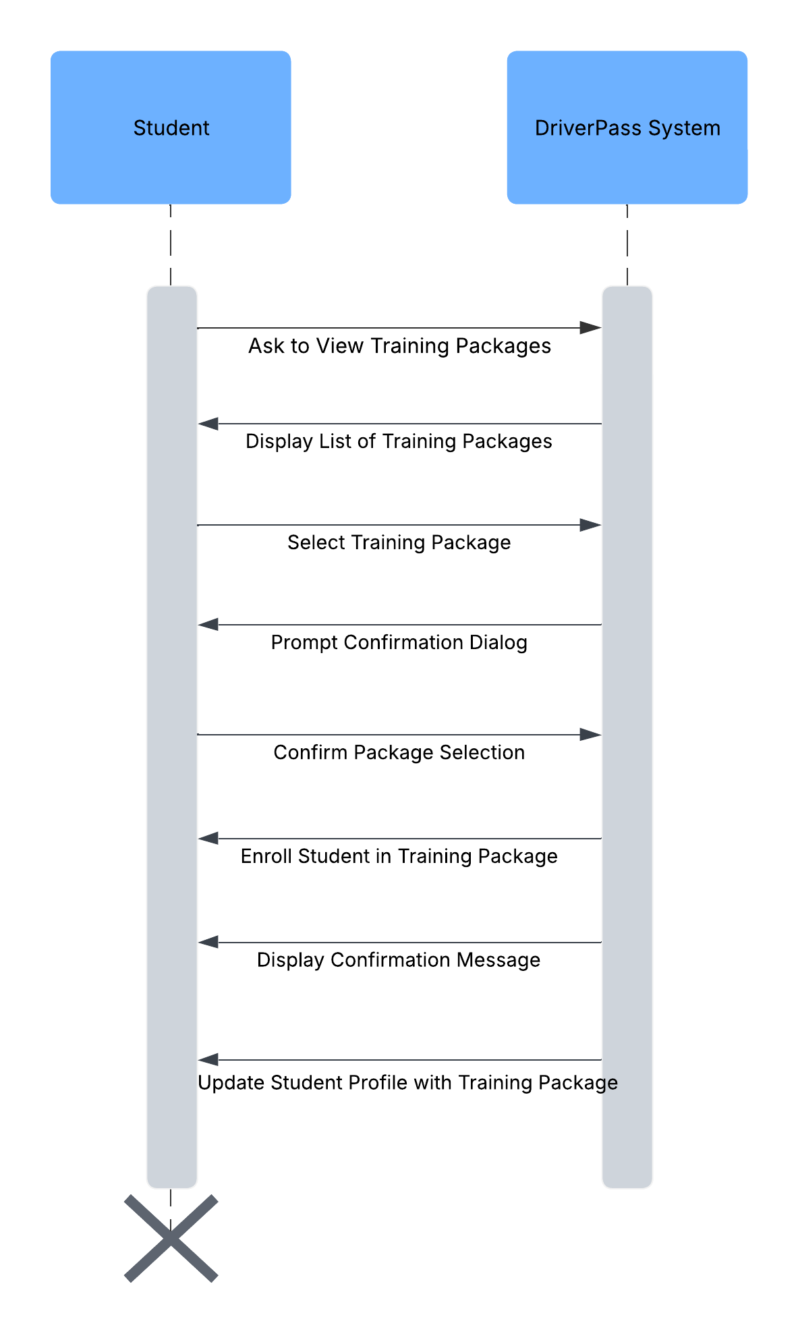

### UML Class Diagram

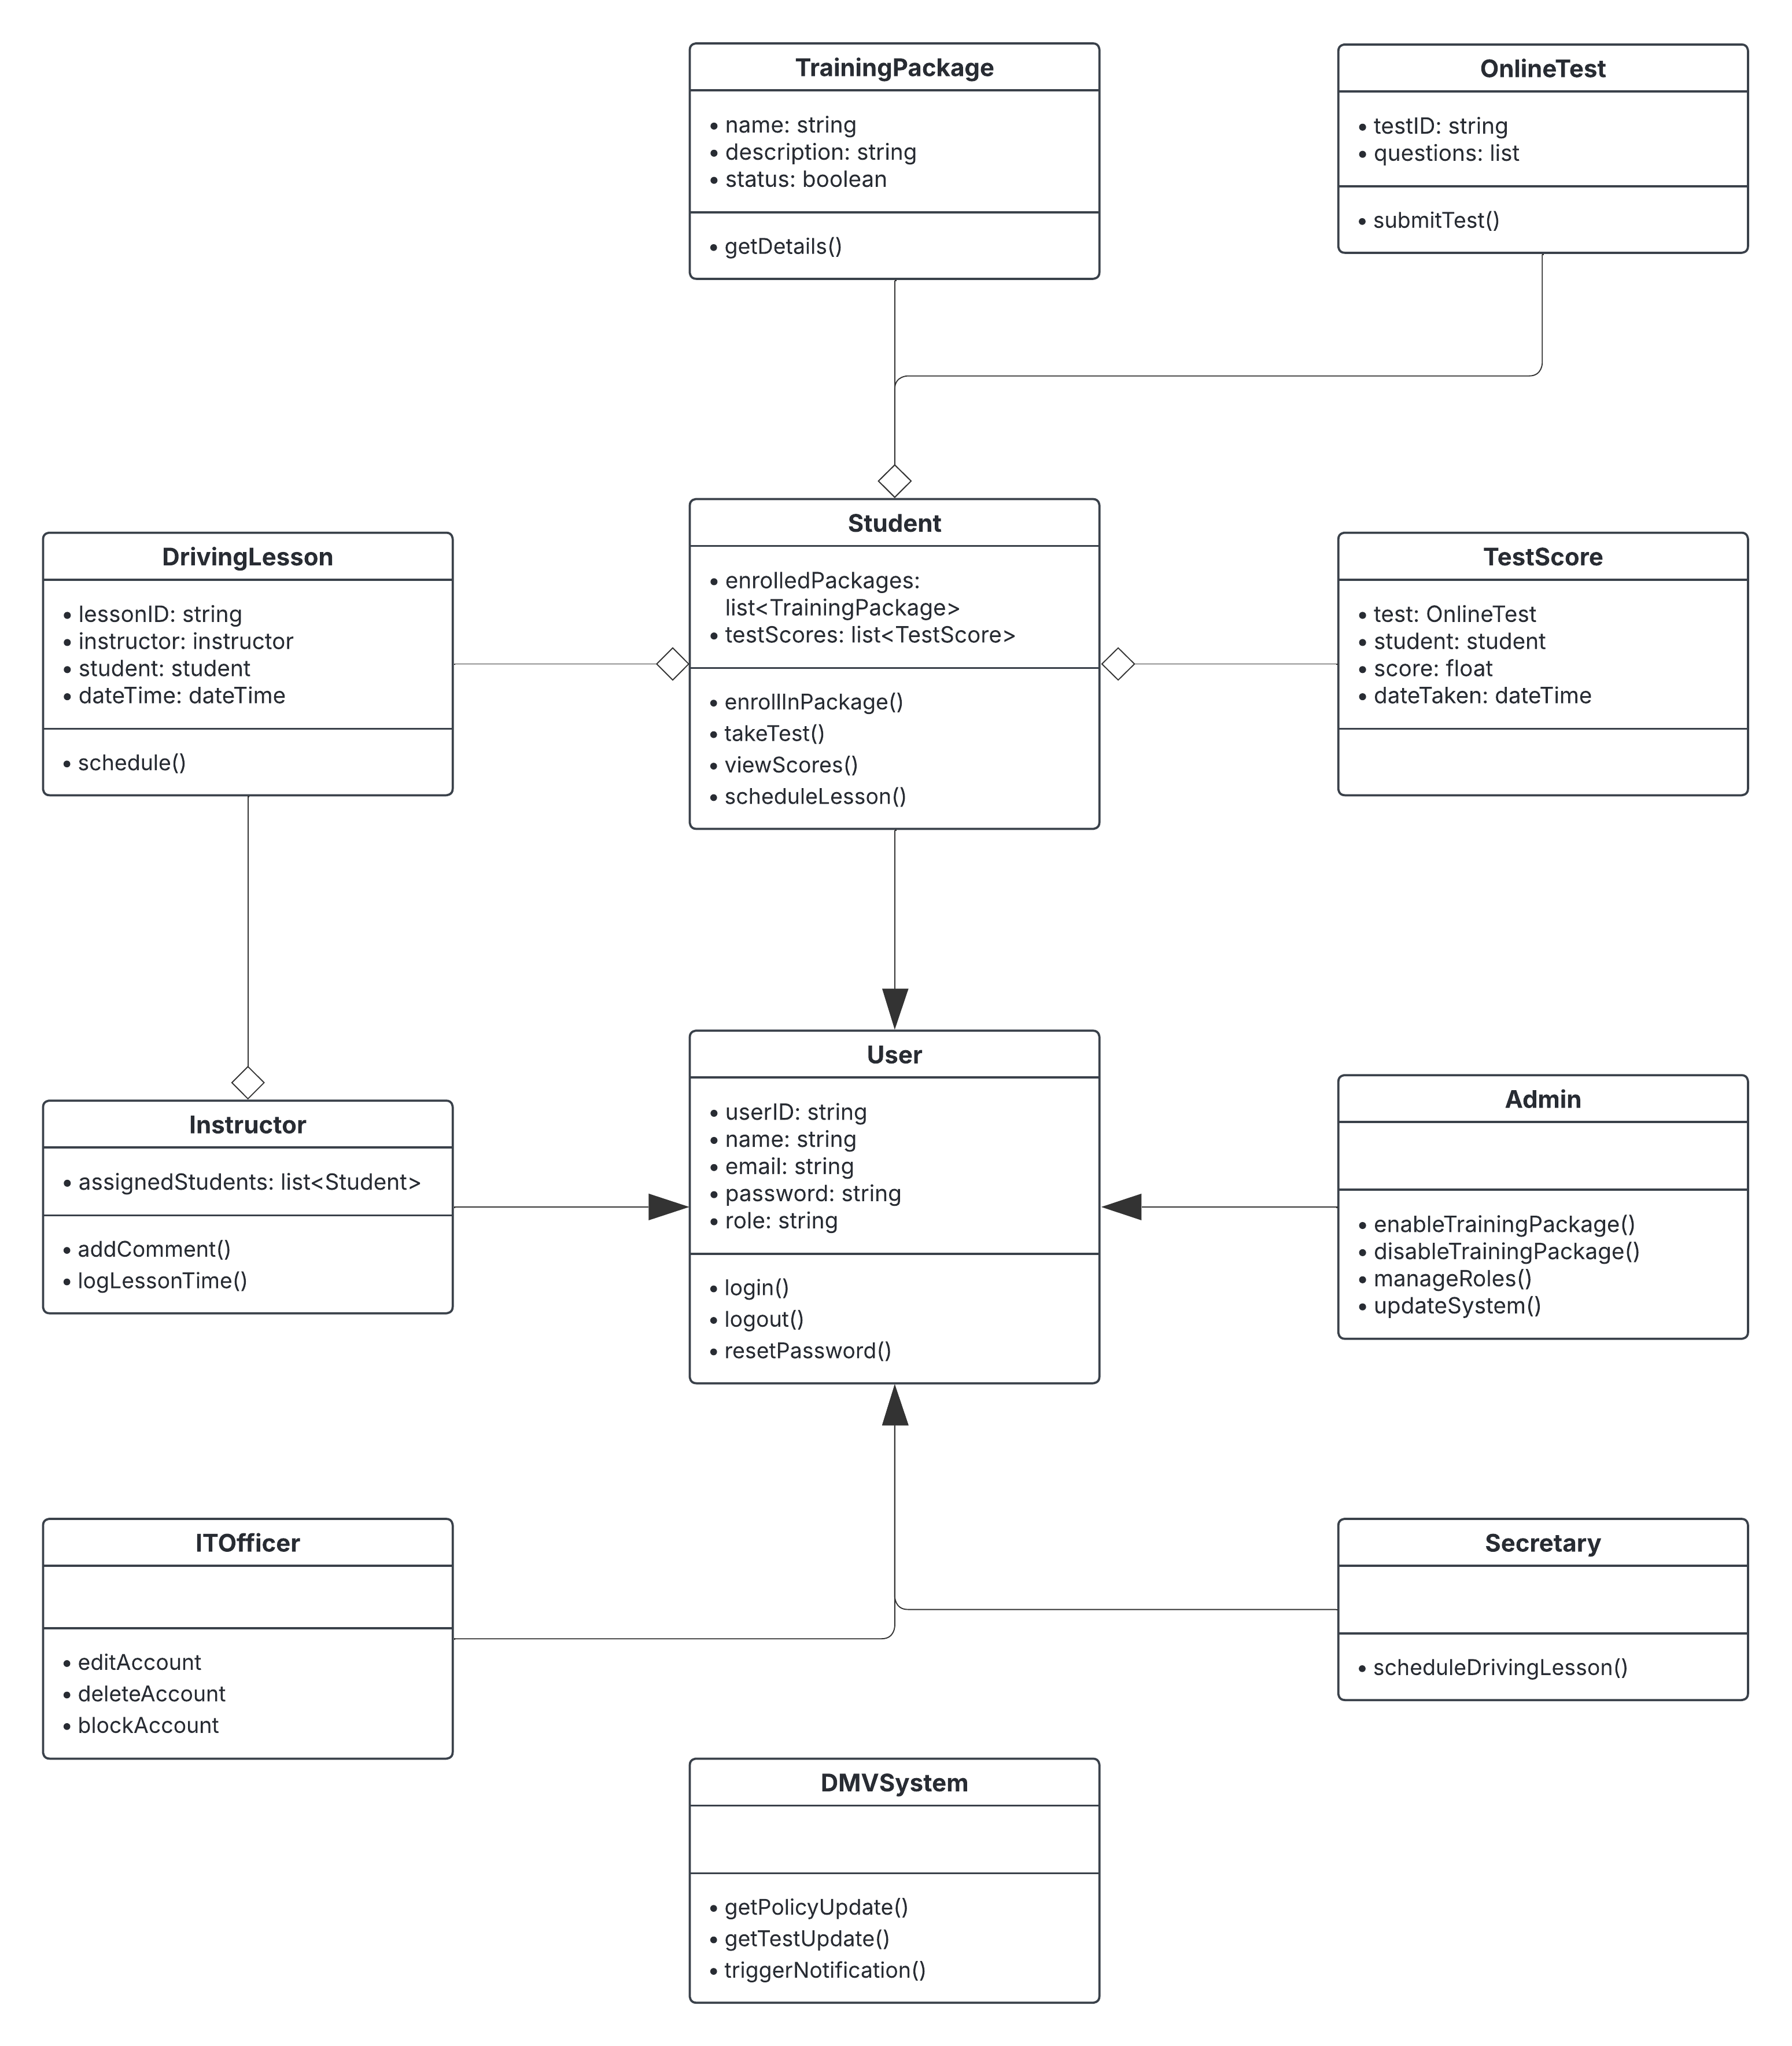

## Technical Requirements

The DriverPass system requires a reliable and modern technical foundation to support its functionality as a cloud-based web application. On the hardware side, the users will need access to desktop computers, laptops, tablets, or smartphones that run either Windows, macOS, Linux, Android, or iOS. A reliable and consistent internet connection is also essential for accessing the system although users will have the ability to download reports for offline use. On the server side, the system will be hosted in a cloud platform such as AWS, Microsoft Azure, or Google Cloud Platform to ensure scalability, security, and automatic data backups. In terms of software, the system will be accessed via modern web browsers like Chrome, Firefox, Safari, and Microsoft Edge. It will also require a database like MySQL to store data including user profiles, test scores, driver notes, training packages, and appointments. The backend will be developed using a server-side language or framework like Node.js, Python, or Java depending on the skills of the development team. The frontend will use HTML, CSS, and JavaScript to build a responsive and user-friendly interface. To ensure security, private user data like passwords will be encrypted using tools like bcrypt. There will be an account lockout mechanism in case of repeated failed login attempts, and notifications to the IT officer in the event of suspicious activity like a brute force attack. These technical requirements ensure that the DriverPass system is accessible, secure, scalable, and ready to handle the needs of the business and its users.